|  |  |
| --- | --- |
| **Status** | Finished |
| **Started** | Monday, 23 December 2024, 5:33 PM |
| **Completed** | Monday, 28 October 2024, 9:22 AM |
| **Duration** | 56 days 8 hours |

Top of Form

Question **1**

Correct

Marked out of 3.00

Flag question

Question text

Write a program to read two integer values and print true if both the numbers end with the same digit, otherwise print false. Example: If 698 and 768 are given, program should print true as they both end with 8. Sample Input 1 25 53 Sample Output 1 false Sample Input 2 27 77 Sample Output 2 true

Answer:(penalty regime: 0 %)

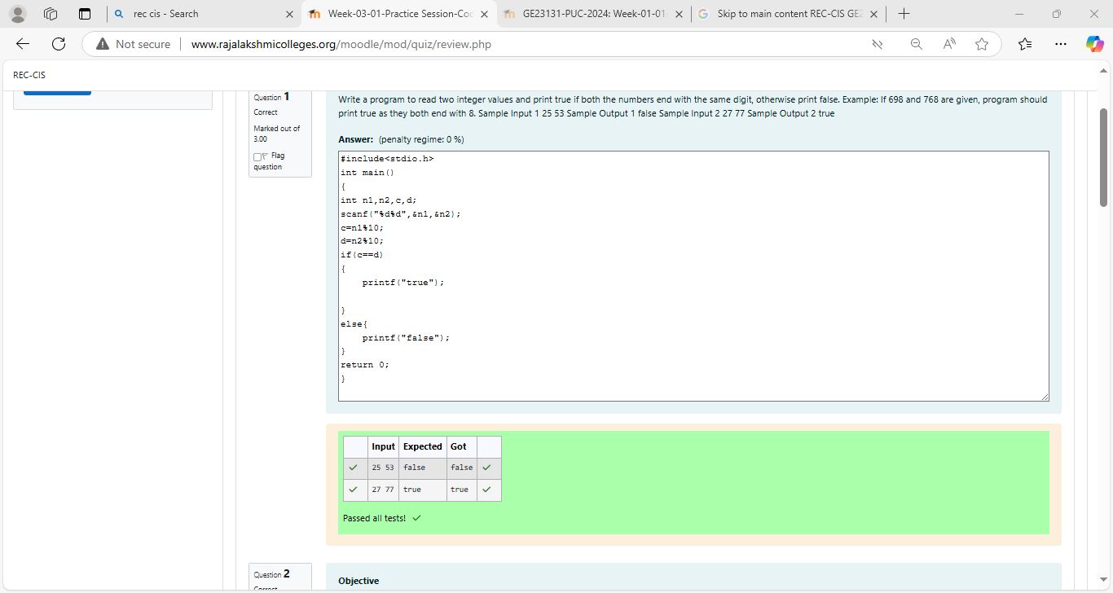

Question **2**

Correct

Marked out of 5.00

Flag question

Question text

**Objective**

In this challenge, we're getting started with conditional statements.

**Task**

Given an integer, ***n***, perform the following conditional actions:

·         If ***n*** is odd, print Weird

·         If ***n*** is even and in the inclusive range of ***2*** to ***5***, print ***Not Weird***

·         If ***n*** is even and in the inclusive range of ***6*** to ***20***, print ***Weird***

·         If ***n*** is even and greater than ***20***, print ***Not Weird***

Complete the stub code provided in your editor to print whether or not ***n*** is weird.

**Input Format**

A single line containing a positive integer, ***n***.

**Constraints**

·         1 < n < 100

**Output Format**

Print Weird if the number is weird; otherwise, print Not Weird.

**Sample Input 0**

3

**Sample Output 0**

Weird

**Sample Input 1**

24

**Sample Output 1**

Not Weird

**Explanation**

*Sample Case 0:*  ***n = 3***

***n*** is odd and odd numbers are weird, so we print ***Weird***.

*Sample Case 1:*  ***n = 24***

***n > 20*** and ***n*** is even, so it isn't weird. Thus, we print ***Not Weird***.

Answer:(penalty regime: 0 %)

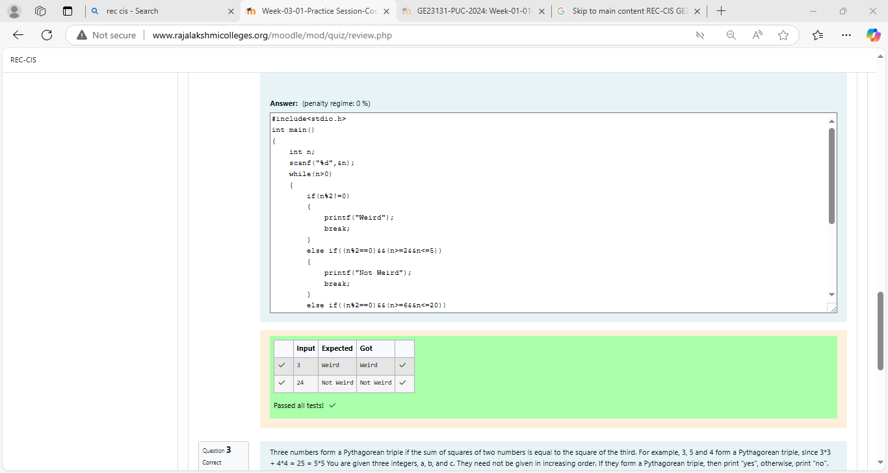

Passed all tests!

Question **3**

Correct

Marked out of 7.00

Flag question

Question text

Three numbers form a Pythagorean triple if the sum of squares of two numbers is equal to the square of the third. For example, 3, 5 and 4 form a Pythagorean triple, since 3*3 + 4*4 = 25 = 5*5 You are given three integers, a, b, and c. They need not be given in increasing order. If they form a Pythagorean triple, then print "yes", otherwise, print "no". Please note that the output message is in small letters. Sample Input 1 3 5 4 Sample Output 1 yes Sample Input 2 5 8 2 Sample Output 2 no

Answer:(penalty regime: 0 %)

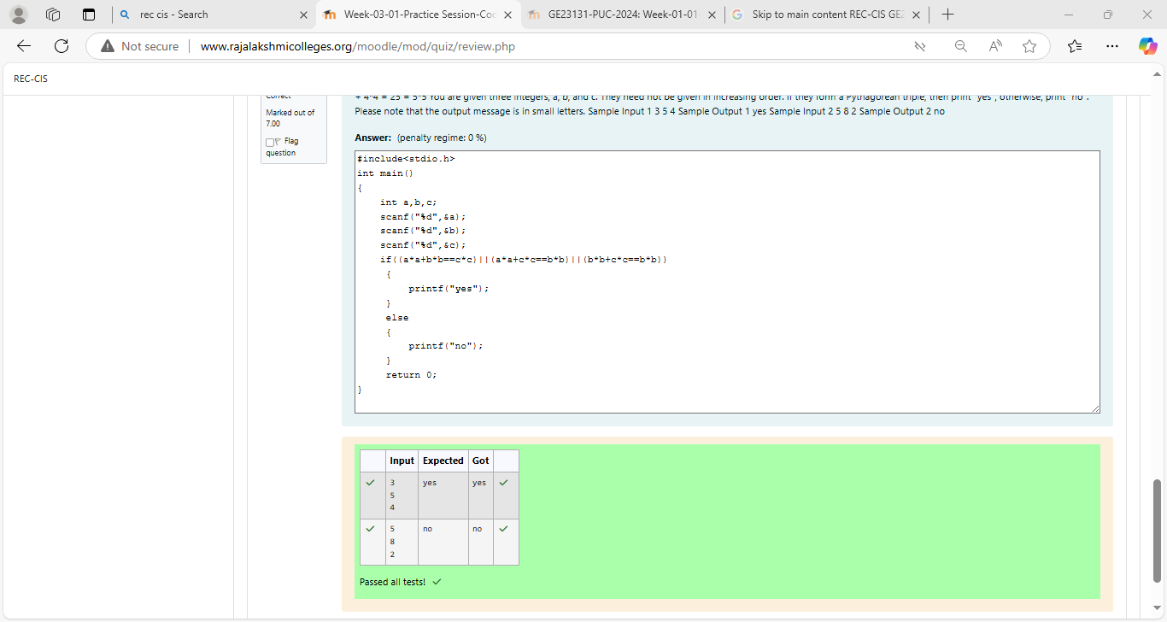

Passed all tests!

Bottom of Form